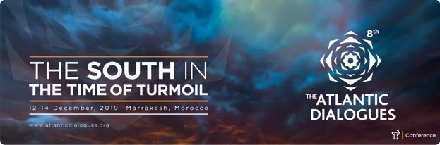
Press Release
Rabat, 6th December 2019

6th Edition of the annual report Atlantic Currents:

« The South in the Time of Turmoil »

Atlantic Currents, a flagship publication of Policy Center for the New South, examines major global issues from a Southern perspective. The 6th edition of this must-read 160 pages document will be released on December 12th and presented by some of its authors in Marrakech, prior to the opening of the 8th edition of the high-level Atlantic Dialogues conference.
In line with the theme of the conference, « The South in the Time of Turmoil », its aim is to cast light on challenges faced by the North and South Atlantic, by voicing the views of the South on the international stage.

From global to local
The Atlantic Currents 2019 edition explores the ongoing challenges faced by the Southern Atlantic, from global to local levels. As emphasized by Karim El Aynaoui, President of the Policy Center, and Bouchra Rahmouni, Director of Research, Partnerships and Events, in their introduction: « Previous editions elucidated how this understudied region is split between a tormented area in the North, and a territory marked by heightened economic, political and social vulnerability in the South. Promoting dialogue and better understanding is key to helping Atlantic countries overcome these fragmentations and choke points and walk together on the road of sustainable development. »
This 9 chapters-long Atlantic Currents Report deals with the broad questions of « the Post-American order », the rule-based trading system « chances of survival », « Cultural Diplomacy » and « The Future of the European Union », before tackling Southern Atlantic issues, such as « The Expansion of Militancy in the Sahel and Worrying Signs to Coastal West Africa », « Women’s leadership in Africa » and « China and Africa in Times of Turmoil », among others.
Experts and Senior Fellows of the Policy Center from the Caribbean region, Costa Rica, Morocco, France and Brazil, have browsed economic, diplomatic and cultural issues through the broad lens used by Aminata Touré, former Prime Minister of Senegal, in the foreword of Africa’s Renaissance: «The Africa we want, is an integrated continent, in which its youth and women have genuine hope for their future, and dream about reaching a level of prosperity and opulence, thus leaving behind them any perception of fear, anxiety, marginalization, exclusion, and victimization in their daily life. »
Women at the forefront
Through a unique perspective on « Women's leadership in Africa » given by Nouzha Chekrouni (Morocco), Senior Fellow at the Policy Center, the report leads by example by including many women as contributors.
Writing on « Global Governance in the Post-American Order » Len Ishmael (Saint Lucia), former Ambassador of the Eastern Caribbean States to the Kingdom of Belgium and European Union, opens the report with reflections on the withdrawal of the US from Western leadership, and its consequences for the South : « As the International Structure continues to take shape and evolve, the message from the global South is simple: Don’t make us choose ! Changing power dynamics and the US view of China more as competitor and threat, than partner, are increasing the sense among many countries, that they are being forced to choose between one side or another. »

Anabel Gonzalez, former Minister of Trade of Costa Rica, examines the stakes at play for the World Trade Organization (WTO) and pleads for a « renewed global trade governance », while former Permanent Representative of the Kingdom of Morocco to the United Nations, Mohamed Loulichki, discusses the implications of a « cultural diplomacy », in a context where the use of hard power has been declining since the end of the Cold War. Dominique Bocquet (France) sheds light onto the entanglement of Brexit, Euroscepticism, and populism as symbols of the new state of affairs, questioning the « future of the European Union ».
Sahel, China and Africa, African agriculture and Atlantic economics
In the second part of the report, Rida Lyammouri (Morocco) looks at the spread and intensification of violent extremist organizations as well as troubling inter-community tensions in the Sahel region, focusing on coastal West Africa.
Moreover, precious insights are given by Marcus Vinicius de Freitas (Brazil) on China and Africa: « A strong temptation to treat China like the Japan or Soviet Union of the past has further emerged, he writes. Yet, both prescriptions are wrong. China is a much bigger economy than Japan was in the 1980s, and has more people and much deeper trade ties with the rest of the world. Additionally, China does not claim hegemony as the Soviet Union used to, nor is it likely to engage in an arms race with the United States. Though some would like to see a new Cold War, this is a scenario that does not take into consideration the Chinese perspective nor its long-term interests, since it would destabilize the vital element of power balance within China’s own neighborhood. »
Fatima Ezzahra Mengoub (Morocco) and Olisaeloka Okocha, a former Atlantic Dialogue Emerging Leader (ADEL) from Nigeria, further discuss the implications and side effects of introducing technology in the African agricultural sector to improve growth. Disruptive technology, they argue, can help solve many issues stunting Africa’s agricultural growth if adequate infrastructures are put into place. Last but not least, the Moroccan economists Tayeb Ghazi and Youssef El Jai draw a comprehensive map of the state of convergence within each sub-region of the Atlantic space, calling for further action to improve the relationships between countries.
As underlined by Karim El Aynaoui and Bouchra Rahmouni, « the report not only offers diagnosis of turbulences in the world order and the Atlantic basin. It brings forwards some promising prospects and pioneering projects, including social innovation as a reaction to societal problems, women empowerment, cultural diplomacy, intercultural dialogue, as well as digital revolution as a force for good and a tool for strengthened cooperation. »

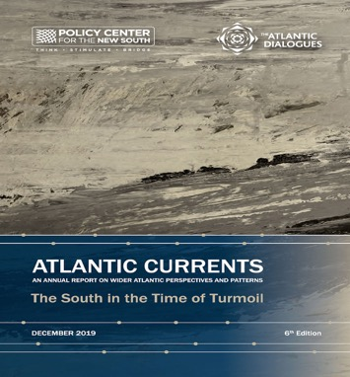

Media Contacts: Atlantic Dialogues
Hasnaa Tadili h.tadili@policycenter.ma , Tel : 212 668 11 60 69
Sabine Cessou scessou@gmail.com, Tel : + 336 70 87 20 05

Atlantic Currents Reports
Maha Skah m.skah@ocppcnet.ma, Tel : + 33 634 57 23 80
About Policy Center for the New South
Launched in 2014 in Rabat with 39 associate researchers from the South as well as the North, the Policy Center offers a southern perspective on the issues of developing countries. It aims to facilitate strategic decisions and public policies in its four main programs: agriculture, environment and food safety; economics and social development; raw materials et finances; geopolitics and international relations. www.policycenter.ma
Follow us on social networks:

